H1: The Ultimate Guide to Surgical Film Dressings: Types, Uses, Manufacturing & more!

Surgical films are versatile and used for a wide range of functions in the healthcare industry.

Medical professionals use adhesive films for surgical procedures, post-op recovery and general wound care.

This guide covers types of surgical films and their medical applications. You will also learn about how specialised adhesive films are conceptualised and manufactured.

If you don’t know enough about surgical films quite yet - start reading to learn more!


Alt-text: surgical film held by medical worker
*from PolarSeal media - need a high quality version preferably.

Table of contents
- What is surgical film dressing?
- Types of surgical adhesive film
- What are the benefits of surgical film dressings
- Manufacturing surgical film wound dressings
- Where can I find a manufacturer for surgical film dressings?

H2: What is surgical adhesive film (dressing) & how are they used?
Surgical adhesive films are used in a wide variety of medical applications.

Surgical films are usually applied during abdominal surgery (for example, a common use is during a cesarean procedure). Adhesive films are used during surgery for a few key reasons.
For one, they protect surrounding areas of skin during operations maintaining a sterile environment for surgical glue and incisions during procedures. They also resist bodily fluids and other outside contaminants.

Healthcare professionals also use medical adhesive films in wound care to maintain an environment that promotes healing. They can also prevent physical damage and interaction with contaminants.

Adhesive films may also be used to fix medical devices to the body for patient monitoring and procedures.

Let’s cover the applications for medical adhesive films and why they are vital in the healthcare industry

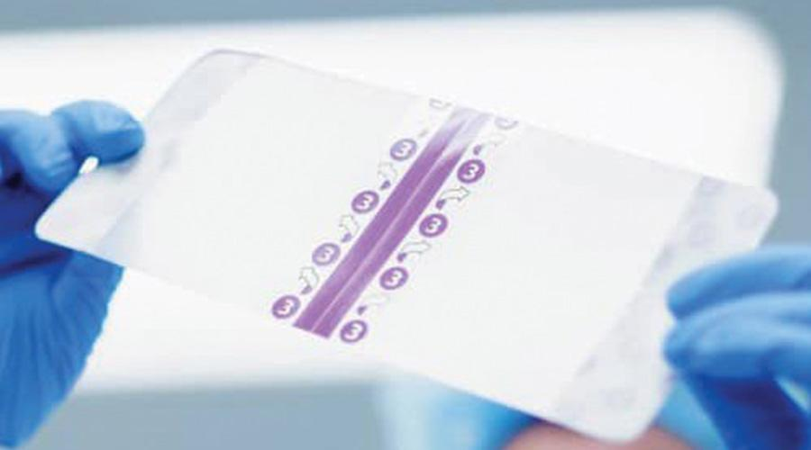
Alt-text: surgical film held by a medical worker - transparent with peel-back adhesive backing.
*from PolarSeal media - need a high quality version preferably.

--

H2: Types of surgical adhesive film dressings & their uses

The manufacturing of surgical adhesive films requires specialised materials and adhesives to fit different medical applications.

Medical manufacturers make surgical adhesive films based on components that fit the practical needs and function of the film or dressing.

Let’s dive into their uses in the medical industry.

H3: Types of surgical films & their uses

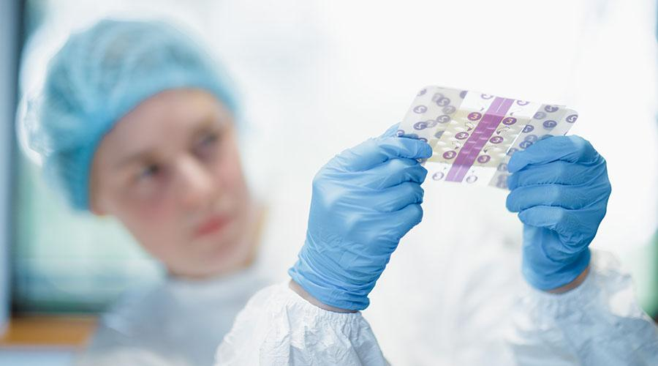
Alt text: medical worker assessing surgical film dressing in cleanroom
*from wetransfer (Shaun)

H4: Incision Films
An incision film, also known as an incise drape, is used during a surgical procedure to provide sterile protection to the skin surrounding a surgical incision and to maintain a surgical glue’s sterile environment during operations.

Incision films are designed for all types of procedures, including abdominal surgery, neurosurgery, orthopaedic surgery, plastic surgery, pediatric surgery and more.

H4: OP Strips
Commonly used to secure and protect incisions during the postoperative healing process.

H4: Bordering Tapes
Used to secure surgical films, medical devices, tubings and dressings to the skin.

H4: Fixation Tapes
Used to secure dresses, bandages, compresses and other medical equipment.

H3: Types of adhesive film dressings & their uses in wound care
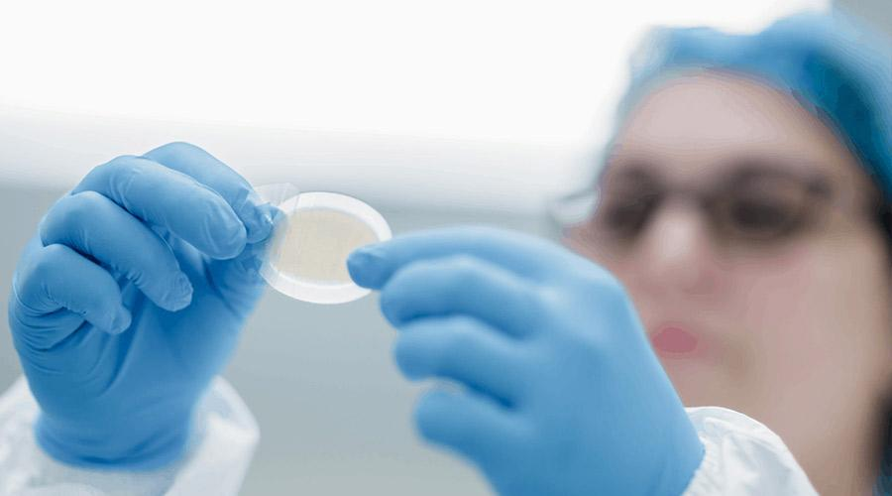
Alt text: medical worker peeling back adhesive on medical film
*from the media gallery on the website.

H4: Island dressings
An island dressing is a post-operative dressing that provides protection for acute surgical incisions.
Island dressings consist of an absorbent surface with an adhesive backing that’s applied to the surrounding skin.
An island dressing’s primary functions are to absorb excess fluid from wounds, maintain a sterile environment and provide a protective barrier against further physical harm.

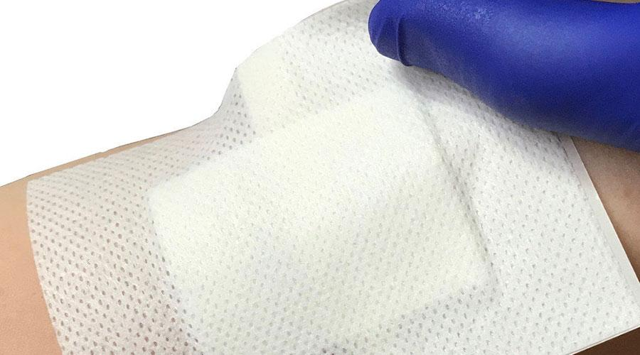
Alt text: island wound dressing being applied to patient’s skin
*source

H4: Foam adhesive dressings
A foam adhesive dressing is comprised of two absorbent layers - a polyurethane pad and a polyurethane membrane. It is also surrounded by a pressure-sensitive acrylic adhesive border. They are designed to care for moderate to heavily exuding wounds.
The polyurethane foam padding absorbs exudate, ensuring that it doesn’t return to the wound or cause maceration (the breaking down of skin tissue due to prolonged exposure to moisture).
The polyurethane membrane ensures transpiration during recovery while providing a physical protective barrier that’s waterproof.

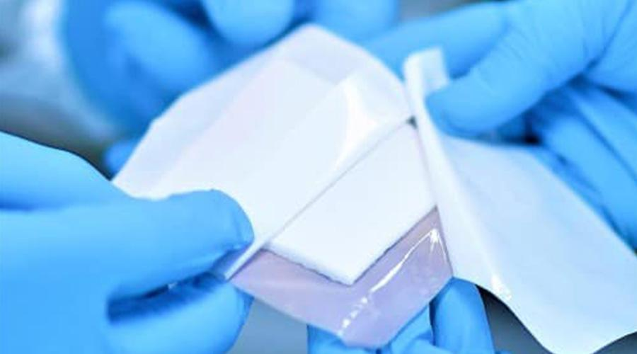
Alt-text: surgical foam film dressing with adhesive border.
*PolarSeal media gallery - requiring a higher quality version.

H4: Hydrogel wound care and hydrocolloid dressings
Hydrogel dressings are semi-occlusive (semi-permeable) and made of hydrophilic polymers with a high (90%) water content. They are typically applied to care for wounds that are dry to moderately exuding.
Hydrogels provide a moist environment for cell migration and the absorption of some exudate.
They promote a breathable environment for effective wound healing. However, they still prevent external fluids from coming into contact with a recovering wound.

H4:Semi-permeable dressings
Semi permeable film dressings are comprised of sterile polyurethane sheets and are coated with hypoallergenic acrylic adhesive.

Semi-permeable medical films struggle to absorb exudate and are therefore not suitable for exuding wounds during recovery. However, they provide the advantage of being able to be applied to hard to handle areas of the body - such as elbow joints.

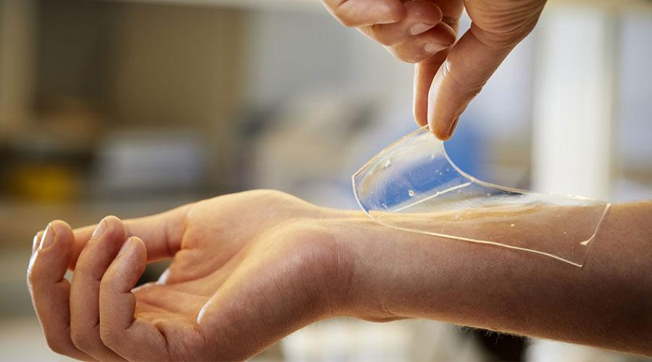
Alt: person applying hydrogel medical film to their skin.
*source

H4: Polyurethane gel dressings
Polyurethane dressings are used to treat chronic wounds. They maintain a moist breathable environment that promotes wound healing and prevents maceration.
H4: Silicone adhesive dressings
Silicone adhesive dressings create an immediate stable seal around skin surrounding wounds - unlike acrylic adhesive films which become more adhesive over time.
They are particularly useful for those with fragile, dry skin and are considered very comfortable.
They also won’t attach themselves to moist surfaces, ideal for a variety of wound care applications.
Soft silicone adhesives also can’t be absorbed by the body, limiting adverse effects (like an allergic reaction)influencing a wound or its surrounding skin.

H2: What are the benefits of surgical film dressings?
Surgical adhesive films for procedures and other medical adhesive dressings for wound care provide a range of benefits.

In short, they are essential for conducting safe and effective procedures, fixing medical devices as well as protecting wounds and ensuring the right environmental controls for recovery.

Let’s jump into the specific benefits of medical adhesive films for surgery and patient care.

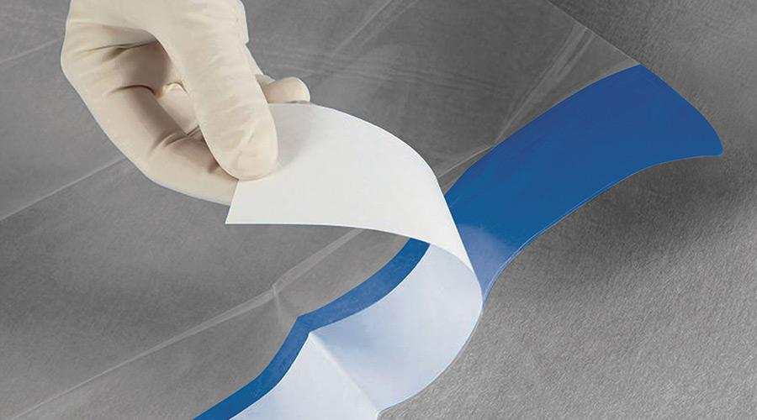
Alt text: adhesive backing being peeled away from surgical fillm
*source

H3: 1. A barrier against viruses, bacteria and other contaminants during surgery.
The specialised adhesive and material barriers that surgical films provide are resistant to fluids and contaminants - making them essential for surgical procedures and wound care applications.

Their resistance to fluids also makes them easy to sterilize with solutions during medical procedures. For surgeons, these adhesive films are the first line of defence against early infections.

During recovery and wound care, adhesive films are essential for effective healing. Once bacteria settle on an open wound, the wound provides the right environment for bacteria to multiply.

Your body will attempt to fight off infection from initial bacteria, but once bacteria have multiplied it becomes harder for the body’s immune cells to clear bacteria and associated infections.

It’s easy to understand why adhesive films are so essential to ensure safety during surgical procedures and postoperative recovery periods.

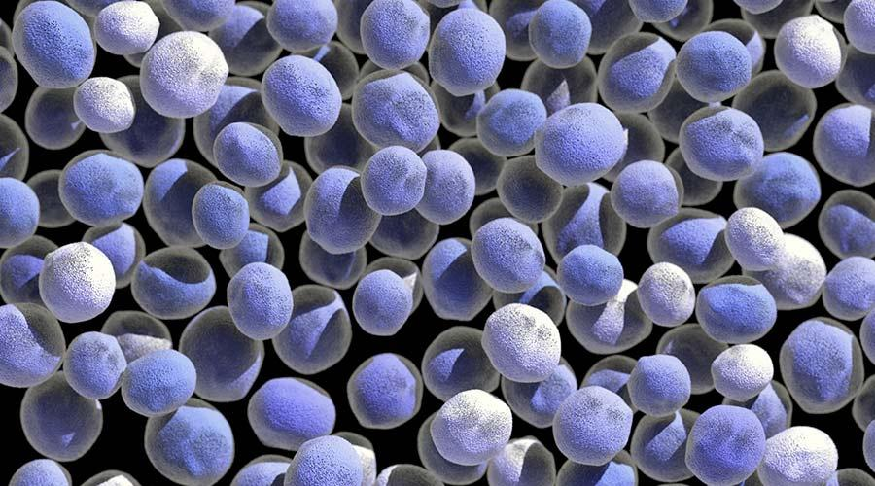
Alt text: bacteria visualization
*obtain from envato elements (covered under license)

H3: 2. Pressure-sensitive & temperature sensitive adhesion

Surgical films can be pressure-sensitive or temperature-sensitive depending on their intended application.

A heat-activated adhesive will not bond at normal temperatures, however, once applied to a surface that emits natural heat (like the body’s skin) - the rise in temperature causes specific chemicals to form a bond with the contact surface.

During application, a degree of pressure may need to be applied to assist in forming an even, steadfast bond between the film and a surface.

H3: 3. Tailored materials suited for different surgical/medical applications & environments

Due to the nature of surgical films being used in various medical applications - there are certain considerations when selecting core materials and adhesives.

Medical adhesive films in wound care might be made of materials that are more breathable while surgical films must be resistant to fluids.

Adhesive films for other medical devices and equipment may need materials that are stronger than others, providing durability and support.

Materials made to produce medical adhesive films can include polyethene, polyethene terephthalate, polypropylene, polyvinyl chloride, polyurethanes and other substrates.

We prefer to use high-performance polyurethanes to develop our surgical films. The right wound care manufacturer can also laminate onto synthetic non-wovens, wovens, or any textiles and integrate single-layer or multilayer constructions.

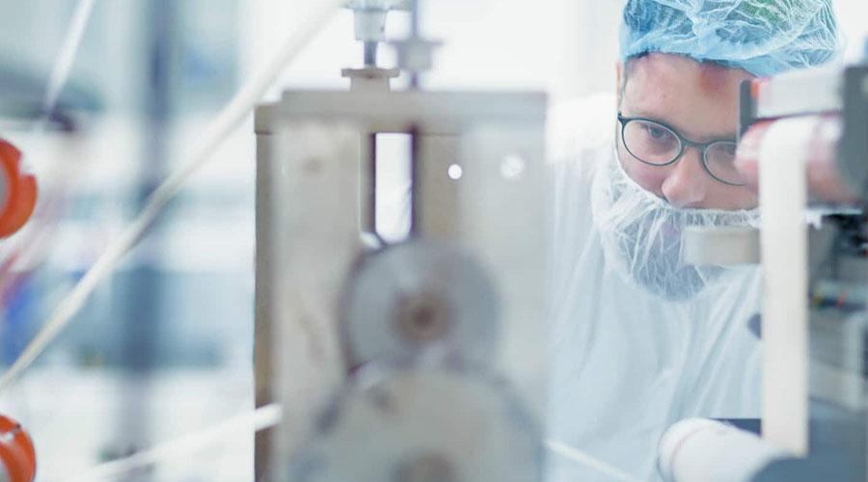
Alt text: medical worker assessing medical device manufacturing machine
*from media gallery on website

H3: 4. Different adhesives tailored for types of surfaces

The key function or purpose of your medical device will guide the adhesive and backing types required for the application.

Depending on the application, you may need to select specific adhesives.

For example, a wound care product that will be placed on the elbow joint will require a great degree of flexibility and durability.

This might not be the case for other adhesive films placed elsewhere on the body, or varying applications.

Surgical films used for procedures may need to form a stronger bond with the skin than others, being able to withstand bodily fluids and other external contaminants. This will require specific skin-friendly adhesives that exclude toxic or harmful elements.

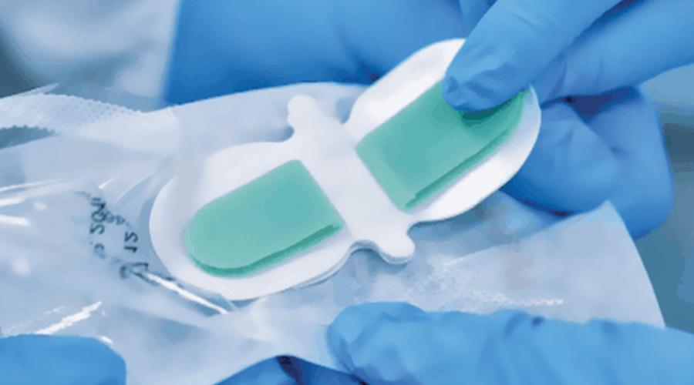
Alt text: adhesive bandage being packaged at PolarSeal
*From media gallery on website

H3: 5. They provide the right environment for effective healing & monitoring

For wound care, it is essential that medical adhesive film dressings maintain a clean environment free from outside contaminants, fluids and environmental irritants.

The materials for medical adhesive films intended for wound care need to promote a healing environment.

For example, types of adhesive films may need to be created with the right materials and adhesives to promote the breathability of wounds and injuries.

Long term recovery of wounds requires a process known as autolytic debridement - which involves the softening of tissue by the body’s processes and enzymes - to take place and this process favours a breathable environment.

Medical adhesive films are crafted with particular substrates and perforation to create different levels of breathability for wound care and injury recovery applications.

Transparent medical films are also effective for monitoring the status of a healing wound without the need to remove wraps of bandaging. Specific injuries might require less exposure to the outside air than others.

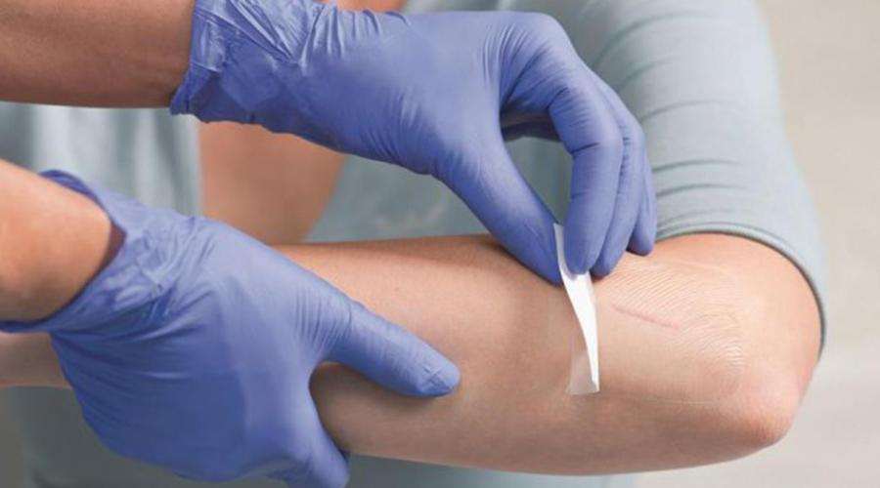
Alt text: transparent surgical film being applied to a wound for care and monitoring.
*source

H3: 6. Medical adhesive films can be made to conform to difficult areas of the body

Surgical adhesive films can be developed to meet all kinds of size requirements fit for surgical applications, securing all shapes of medical devices and wound care applications.

For example, we provide tailored cutting services when developing adhesive films to meet specific surgical and wound care needs.

In essence, surgical films are a flexible solution for all types of medical professionals treating patients across the globe.

H2: Manufacturing & Design Considerations for surgical film dressings

There are many aspects to consider during the conceptualisation and production of surgical
films and other medical adhesive films and dressings.

Due to the nature of surgical films’ application, a production process that is precise and sterile is imperative to creating and distributing a high-quality product.

Let’s find out about the aspects to consider when producing surgical film dressings.

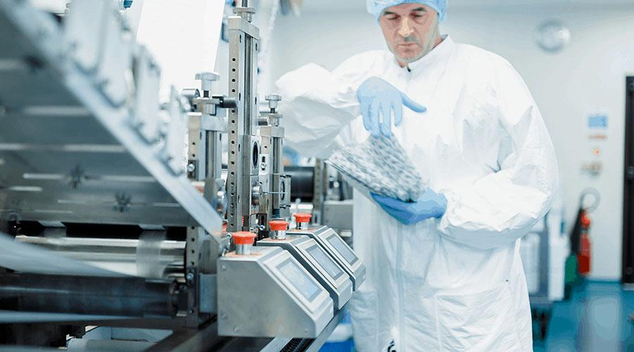
Alt text: medical lab worker manufacturing surgical films with specialised machinery.
*from media gallery on website

H3: Purpose/application of surgical film

The purpose behind the medical application intended for a surgical film will guide the adhesive, substrate and accompanying elements necessary for production.

Whether your medical adhesive film will be used to accompany wound dressings, secure medical devices and equipment, or be used during surgical procedures will ultimately determine the strength of materials, type of adhesive you require and it will inform the overall design of the product.

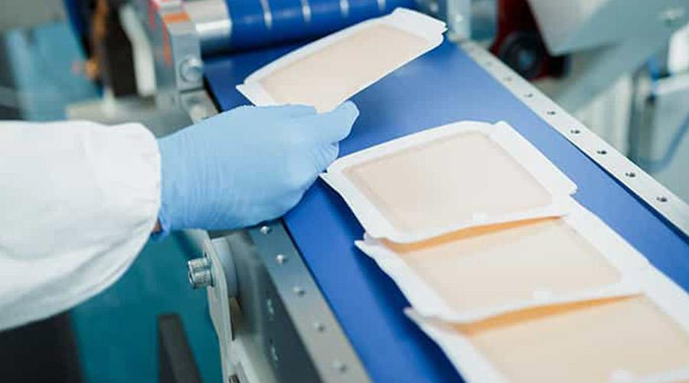

Alt text: film dressings in packaging
*from website media gallery

H3: Product design & packaging

There are various components to be considered when designing surgical films.

A medical adhesive film comprises a layer of polyurethane (or another substrate), a specialised adhesive, release liners, finger-lift areas, handling bars for branding, and packaging.

Polyurethanes are used for a large number of applications not limited to the medical industry - packaging, furnishings, electronics, flooring, boating, construction, clothing and the automotive industry.

Surgical films also need appropriate packaging that is sterile and ready for application.

Producing surgical films and a final packaged product that can be safely subjected to the strict sterilization procedures required for medical products (such as gamma and ETO sterilization) is essential.

It is the industry standard that medical products are subjected to gamma and ETO sterilization procedures, and once subjected to sterilization a medical product’s physico-chemical properties and its effective medical application can be affected.

Medical products require strict sterilization procedures that don’t involve the use of fluids, raised temperatures, and can’t leave minimal or any residue.

Of course, design elements such as your branding, colour scheme and information about your product specifications need to be considered when designing your packaging.

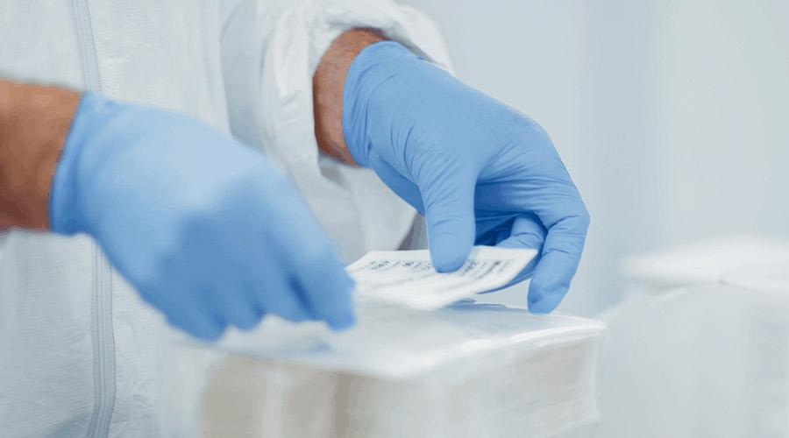
Alt text: medical worker applied labelling to a packaged medical device
*media gallery on website

Aspects to consider:

- Retention or removal of the polyethylene support film
- Liners – including printed liners for brand recognition
- Handling bars in a custom colour to match brand or application
- Folding and packing into a sealed pouch, sterilised and ready for use
- Products suitable for gamma and ETO sterilisation procedures

H3: Certifications required for surgical adhesive films

Surgical adhesive films require strict certifications to be used for different medical applications.

The medical industry requires that medical adhesive films have CE marking aligned with the EU Medical Device Regulation (MDR) 2017/745.

Finding a medical producer that has obtained ISO 13485 is essential to ensure that they have the proven ability to create high quality, approved medical devices.

Other international standards may be applied, including ISO 10993-5 and ISO 10993-10 which cover aspects related to adhesives being tested for cytotoxicity, skin irritation and skin sensitization.

H3: Cost of manufacturing surgical film dressings
The cost of manufacturing surgical film dressings is variable depending on the quantity of the order and the design of the packaged product.

It’s hard to estimate the cost to manufacture surgical films without knowing your specific requirements and medical applications for which they are intended.

We would recommend contacting us to find out more. We manufacture our medical products in cleanrooms produced and maintained under ISO standards and in alignment with industry-standard certifications.

H2: How are surgical adhesive films manufactured?

Another consideration when producing surgical films is the process behind converting your intended materials into a high quality finished product that adheres to strict production standards.

The manufacturing process is multifaceted and involves intricate crafting processes that meet components characteristics, shape, format and application - while ensuring the right adhesive is chosen so the product can succeed in its medical application.

Here are the three main elements of the manufacturing process:

H3: 1. Selecting Materials

Depending on the application, specific materials will need to be selected based on their functionality.

Some materials used to develop surgical films will need to be light, breathable and flexible, whilst others might need thick and stiff to meet the requirements of their application.

The selection of materials will also impact on the kind of adhesive that will be used to develop the finalised product.

For example, surgical tape is generally made of a porous material, like 3M Micropore and paired with a hypoallergenic adhesive that holds firm while allowing the skin to breathe and doesn’t damage the skin upon removal.

When producing a surgical film, expect to find some of the following material options:

- Polystyrene - low cost clear, hard, and brittle resin.
- Polycarbonate - strong, tough materials easily worked, molded, and thermoformed (some grades are transparent).
- Acrylics - strong, stiff material with high optical clarity that is easy to fabricate, bonds well with adhesives and solvents, and is easy to thermoform..
- Silicone rubber - rubber-like material resistant to extreme environments while retaining function.
- Polyethylene - this material has low strength, hardness and rigidity, but has a high ductility and impact strength as well as low friction with a waxy feel and good electrical insulation properties.
- Polypropylene - similar to polyethylene, but harder and more resistant to temperature.
- Synthetic rubbers - offer a different range of physical and chemical properties, are superior to natural rubbers in thermal stability and resistance to oils, and are more resistant to oxidizing agents than natural rubber.

H3: 2. Tape Converting & Adhesive

Medical adhesive tape (or surgical adhesive tape) is used for a variety of medical applications - from holding an incision closed before stitches, to attaching bandages to wounds, or as a replacement for stitches, fixing medical devices to the body and more.

Due to the wide range of applications for surgical adhesive tape, a medical manufacturer needs to provide a wide variety of lengths, widths, materials and styles of tape to suit your application.

Some of the most common adhesives used for surgical films include acrylics, epoxies, silicones, styrene block copolymers, and PSAs.

Keep in mind that adhesives for surgical procedures may need to be hypoallergenic, withstand repeatable skin contact, sterilization, conform to custom shapes and surfaces, contain elongation properties, and meet other standards.

Pressure sensitive adhesive tapes which lend themselves to laminating operations during conversion are commonly manufactured in the form of transfer tapes, single coated tapes or double coated tapes.

{image}  Transfer tapes | {image}  Single-coated tapes | {image}  Double-coated tapes

These converted products each aim to improve the quality of a product and ensure effective application, while reducing cost.

We convert surgical tape into specifically sized rolls, and die cut or slit tape to fit your needs.

Our expertise and knowledge help us inform businesses about the best product based on performance and pricing. Our team has the skills and know-how to handle and convert medical tape products to your exact requirements.

We are able to source and provide reduced lead times for samples, prototypes and full orders of surgical tape. We use a wide range of tape products to create bespoke solutions for our clients.

H3: 3. Die Cutting Materials/Components

Die cutting is the process of using a die (a specialized machine tool used to cut material to a desired shape) to cut materials such as fiber, cloth, paper, and pressure-sensitive adhesive tapes amongst others.

To produce a die-cut, certain parameters need to be assessed such as material type, tolerance, volume, and final presentation required. Once these have been assessed and the feasibility of producing the required die-cut ascertained, the machine and tool type is then selected

There are different types of die cutting methods available to suit various materials. Flatbed medical die cutting, rotary medical die cutting and large format die cutting.

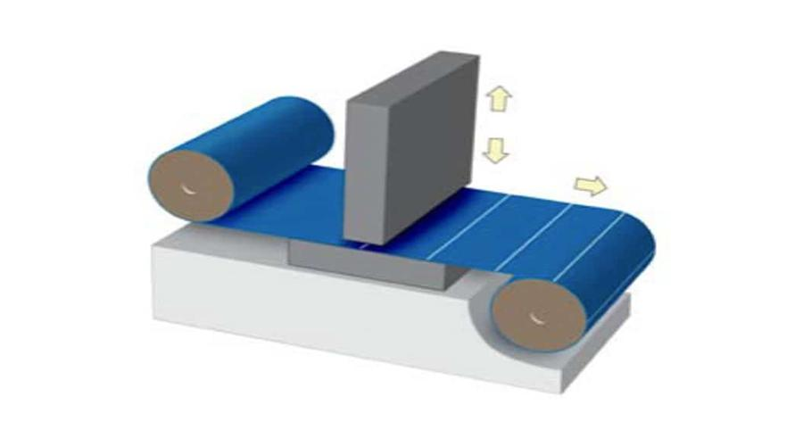

Flatbed medical die cutting utilises a flat fixed base and a moveable head, where the cutting die is typically made from sharp strips of metal called “steel rule”. They can through-cut or kiss-cut similar to rotary presses and their cutting die is typically made from sharp strips of metal called “steel rule”.

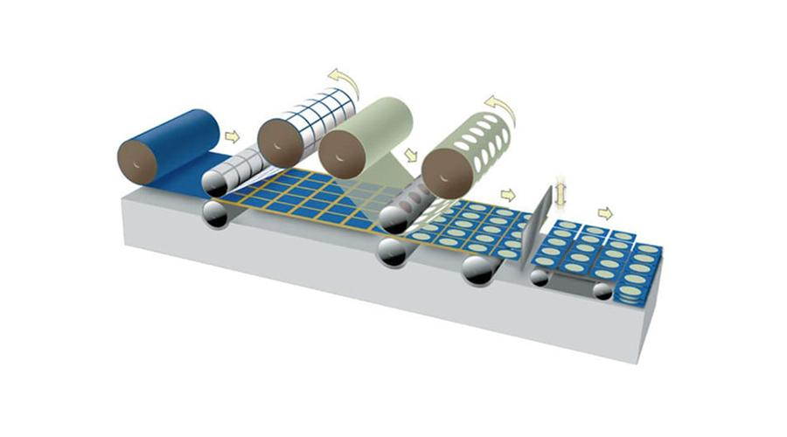

Rotary die cut presses are fitted with an extensive range of innovative capabilities that makes it possible to configure a range of medical devices, providing almost endless possibilities in terms of presentation, style and format.

Rotary medical die cutting can be combined with lamination, multi-layer substrates, printed backing papers and sheeting in a single pass. Capabilities also include perforation of materials to aid breathability and product design.

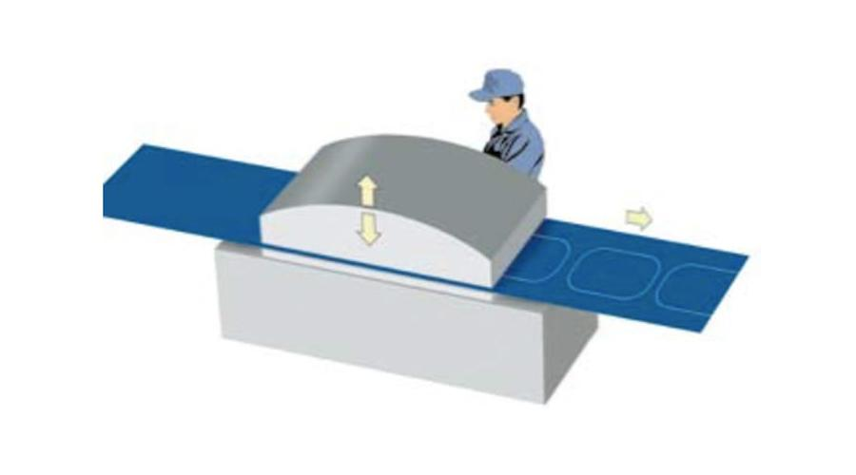

For larger format, specialised medical device applications it is also common for medical manufacturers to provide the capabilities to create larger size die cuts. PolarSeal provides very large-scale die-cuts up to 1600mm x 800mm in size.

H2: Where can I find a manufacturer for medical adhesive films?

Your prospective medical manufacturer needs to instill complete confidence in their abilities. An established track record indicating expertise and experience producing high quality medical devices in alignment with international standards is crucial.

Vetting your medical manufacturer is a great way to ensure that the specifications of your medical device are met in full.

We would suggest reviewing their references, medical partnerships and consider getting sample products produced for your reference.

We are a contract manufacturer of medical devices for the global healthcare market - ranging from advanced wound care products to ground-breaking diagnostic applications. We deliver fully qualified products within limited turnaround times that adhere to the ultimate quality standards for various markets around the world.

Contact us to find out more about our medical manufacturing capabilities to suit your application!

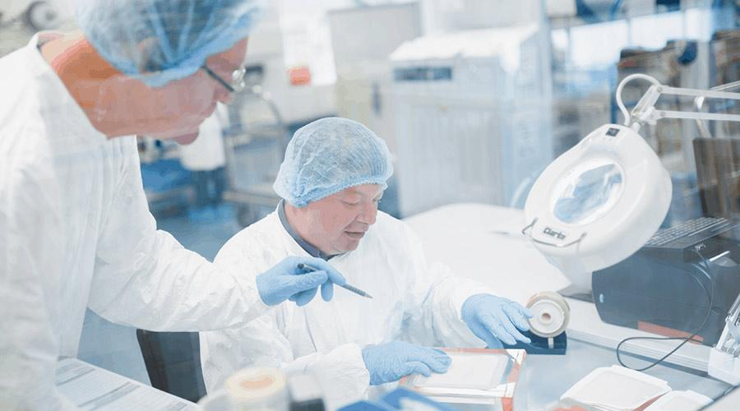
Alt text: medical workers working inside cleanroom at PolarSeal
*sourced from media gallery

Meta title | Ultimate Guide to Surgical Films: Types, Uses, Benefits & more! | PolarSeal (75 characters)
Meta description: | Learn about all types of surgical films & adhesive films for medical applications, their benefits & manufacturing. Read more on PolarSeal! (138 characters).

Keywords to consider  Keyword research sheet | - Incision Films  - Film dressing  - OP Strips  - Bordering Tapes  - Fixation Tapes  - adhesive film  - surgical film(s)  - Medical film (careful)  - support film

Resources/references:

General
- https://www.adhesiveplatform.com/medical-adhesive-film-for-operations-theaters/
  - Really liked this resource
- https://www.encyclopedia.com/medicine/encyclopedias-almanacs-transcripts-and-maps/incision-care-0
- https://www.thomasnet.com/articles/adhesives-sealants/types-of-medical-adhesives/#:~:text=Acrylics%2C%20or%20cyanocrylates%20(CA),for%20bandages%20and%20disposable%20applications.
- https://www.ncbi.nlm.nih.gov/pmc/articles/PMC5820857/

Gamma Sterilization
- https://www.ncbi.nlm.nih.gov/pmc/articles/PMC5820857/

Polyurethane applications:
- https://polyurethane.americanchemistry.com/Applications/

Maceration
- https://www.nursingtimes.net/clinical-archive/tissue-viability/the-causes-and-prevention-of-maceration-of-the-skin-01-11-2001/#:~:text=Maceration%20is%20defined%20as%20the,described%20by%20Charcot%20in%201877.

Types of medical adhesive films
- https://pubmed.ncbi.nlm.nih.gov/26763565/
- https://www.smith-nephew.com/key-products/advanced-wound-management/allevyn/allevyn-non-adhesive/
- https://www.vitalitymedical.com/optifoam-non-adhesive-foam-dressing.html#:~:text=Medline%20Optifoam%20Non%2DAdhesive%20Foam%20Wound%20Dressings%20are%20a%20primary,maintain%20an%20effective%20healing%20environment.&text=The%20dressing%20contains%20no%20adhesive,to%20keep%20it%20in%20place.
- https://dermnetnz.org/topics/silicone-dressings/
- https://www.medicalexpo.com/prod/pharmaplast/product-69684-833379.html
- https://www.woundsource.com/product-category/dressings/transparent-films
- https://www.healthline.com/health/pressure-bandage

Heated adhesives:
- https://www.strouse.com/blog/heat-activated-adhesives

Medical adhesive compositions:
- https://www.thomasnet.com/articles/adhesives-sealants/types-of-medical-adhesives/#:~:text=Acrylics%2C%20or%20cyanocrylates%20(CA),for%20bandages%20and%20disposable%20applications.

